Ex.No : 21

DCL COMMANDS

mysql> use test;

Database changed

mysql> CREATE USER 'ashwathi'@'localhost' IDENTIFIED BY 'ashu';

Query OK, 0 rows affected (0.09 sec)

mysql> select user from mysql.user;

+----------+

| user |

+----------+

| ashwathi |

| root |

+----------+

2 rows in set (0.00 sec)

mysql> GRANT ALL PRIVILEGES ON student TO 'ashwathi'@'localhost' WITH GRANT OPTION;

Query OK, 0 rows affected (0.00 sec)

Microsoft Windows [Version 10.0.22000.856]

(c) Microsoft Corporation. All rights reserved.

C:\Users\Ashwathi V>cd\

C:\>cd program files

C:\Program Files>cd mysql

C:\Program Files\MySQL>cd mysql server 5.5

C:\Program Files\MySQL\MySQL Server 5.5>cd bin

C:\Program Files\MySQL\MySQL Server 5.5\bin>mysql -u ashwathi -p

Enter password:

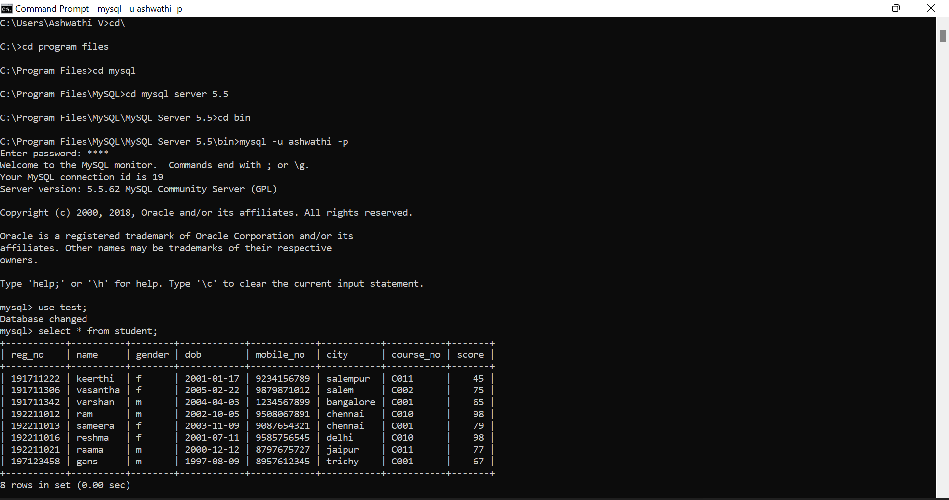

mysql> REVOKE ALL PRIVILEGES ON student FROM 'ashwathi'@'localhost';

Query OK, 0 rows affected (0.00 sec)

mysql> select \* from student;

ERROR 1142 (42000): SELECT command denied to user 'ashwathi'@'localhost' for table 'student'